**List 3 words that describe your proposal:**

Augmented-Reality, Exploration, Sound-Visualization

**One sentence description of the work:**

A collective playful experience with the sound sculpture generated in space

**Full description of the proposed project:**

User will download this app from app store via QR code, open the app, there are 2 ways of interaction, turn on the microphone, hold the recording button at the bottom of the screen and start to record voice (it could be any content, for instance, random talking, stories, diaries, singing…but maximum duration is 1 minute). As the user recording their voice they could move around with the phone, and they will see a sound-wave line created in the space following their motion position. The “sculpture” will permanently be there in the space, and the other way of interaction is other users can also see the sculpture created by their friends, and when they go along the sculpture, trying to walk the way, move the movements their friends did, they can hear the playback.

**What is the concept? In what ways does your project inspire dialogue about issues, relationships, stories?**

It sounds like audio social media posts placed in a mirror world, it is also a new way of storytelling. It could be considered as a site specific experience, only in certain place and by certain moves could you perceive the 1-minute experience created by the previous users, people can feel how the “sound” creator was going through in that minute at that specific place by moving the way he/she moved.

**Why do you consider this project to be a meaningful exploration of video sculpture?**

Sound is usually not being perceived by sight in our physical world, people’s voices is unique, they all have their own features and identities, we encourage people to leave their stories as a form of sculpture up in the air waiting for others to discover. AR is one of the best ways to reveal something that cannot be viewed by our eyes and overlap it to the real world, it is not only meaningful to explore how sound could be visualized in an AR experience, but also it is an exploration to site specific story telling.

**Describe your plan for installation**

As this is actually a smart phone app, user could download the app from a QR code sticker on the wall, along with a caption, and there should be a demonstration video beside the QR code if this is installed in an exhibition.

**Include a wireframe**

**A sound sculpture generated**

**Record the story**

**Record the story**

**Open up the app**

**Move around**

**Get notification of nearby stories based on location**

**Get to the place according to the map to “experience” the story**

**Walk to certain places**

**Get notification of friends’ stories update**

**Below is a rough sketch of the idea before this one, inspired by city sound walks, we would like to create an AR sound walk, when in the walk, waveforms of the narrative audio are floating in the air to guide people where to go.**

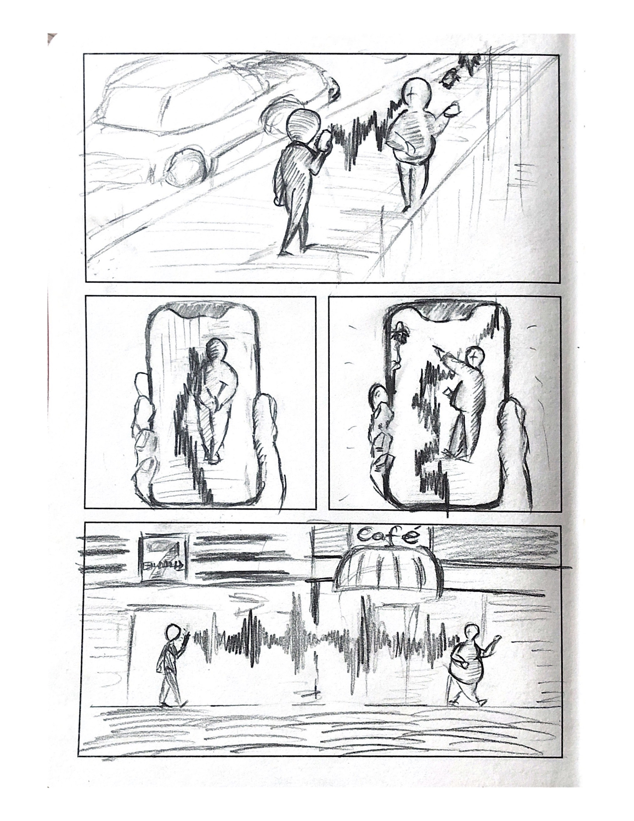

**Include your artist statement**

Chenhe Zhang, also known as Nick, is a multi-media artist whose work focuses on re-interpreting classic art pieces and ordinary everyday objects, exploring new forms of embodiment of east Asian cultures and creating fun experience. His inspiration came from everything from everyday life and the culture he grew up with. Friendly and playful expressions are always key in his work, he does not want the audience to think too much or too deep about his work, but to enjoy the moments interacting with them.